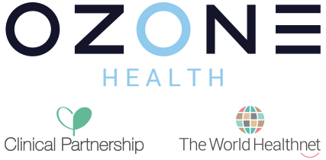

Equality and Diversity
Annual Workforce Report
2022

If you would like help translating this information into another language, or you would like this information in Braille, large print or audio format, please get in touch with us.
Call: 01482 908208 or Email HR@ozonehelth.co.uk

Welcome to the Equality and Diversity Annual Report.
Welcome to our equality and diversity report 2022. Ozone Health Ltd is the overarching board and governance for Ozone Health Ltd (OHL) Clinical Partnership (CP) & The World Healthnet Ltd (WHN).

Ozone Health Group are committed to providing first class healthcare and healthcare IT services for our diverse population, recognising that services need to be designed with the person at the centre of them, ensuring equality, diversity, inclusion and human rights are our business and shape and influence our decision-making.
This report must be read against the backdrop of what we can only describe yet another challenging year for all healthcare providers.
This report demonstrates our commitment to a culture where those working for us are valued and appreciated for the skills and talents they bring to the organisation, and where the needs of those using our services are understood and respected. We are committed to treating everyone who visits or works for us with respect and as individuals, taking into account their individual differences, personal values and perspectives.

Our aim is to make equality part of our everyday work, to ensure that our main focus is providing a workplace where employees feel comfortable to be themselves and to provide the best service to our users.

Holly Hellstrom
Information Assurance Director

Introduction
The key areas of our statutory, mandatory and regulatory obligations are set out below:

Equality Act 2010 and the Public Sector Equality Duty (PSED) - The Equality Act 2010 replaced previous anti-discrimination laws with a single act. It gives the NHS and its organisations opportunities to work towards eliminating discrimination and reducing inequalities in care. The Public Sector Equality Duty applies to public bodies and others carrying out public functions and requires these organisations to publish information to show their compliance with the Equality Duty. The information must show that the organisation has had due regard to the need to:

- Eliminating unlawful discrimination, harassment and victimisation;

- Eliminating unlawful discrimination, harassment and victimisation;
- Advancing equality of opportunity between people who share a protected characteristic and people who do not;
- Fostering good relations between people who share a protected characteristic and people who do not share it.

As an NHS provider we aim to provide accessible services that respect the needs of each individual and exclude no one. The organisation is committed to eliminating any form of discrimination based on the Equality Act, which identifies the following protected characteristics:
Disability, Sex, Race, Religion and Belief, Sexual Orientation, Age, Pregnancy and Maternity, Marriage and Civil Partnership, Gender Reassignment.

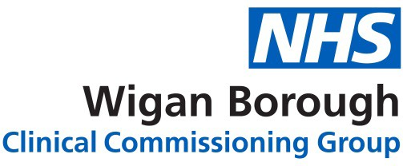
Our Duty & Responsibilities
As an NHS provider we fully embrace our equality duties, and our Equality and Diversity report demonstrates how the Group is meeting Equality Duties and NHS England (NHSE) Equality Standards. The report reflects our ongoing journey of development and improvement.

As a service provider, we are committed to providing a service, which is accessible to everyone and prevents unfair or unlawful discrimination on the grounds of age, disability, sex, gender identity, race, sexual orientation or religion, faith or belief. We are working to promote good relations between different individuals and groups.

As an employer, we will ensure our employees work in an environment, which respects and includes everyone and is free from discrimination, harassment and unequal treatment. We are keen to attract staff from diverse backgrounds that are representative of the population we serve and seek to raise our profile as a potential employer, especially where we are under-represented.

We have specific duties as a provider to; publish relevant, proportionate equality information to demonstrate our compliance. This must include:
- Information relating to employees who share protected characteristics.
- Information relating to people who are affected by our policies and practices, who share protected characteristics
- Prepare and publish equality objectives

Accessible Information Standard
The purpose of the Standard is to meet the communication needs of patients, service users, carers and parents. The Standard aims to establish a framework and set a clear direction so patients can receive information in their preferred format e.g. Braille, Easy Read or British Sign Language Interpreter. The organisation has fully implemented the Accessible Information Standard.

Through our list of preferred providers, the organisation is able to offer interpretation and translation services in the following formats:
- Face-to-face interpretation and translation
- Telephone interpretation and translation

Equality core principles
The organisation has already produced an Equality and Diversity Policy; we have agreed a set of core principles that underpin the development and delivery of our ambitions and priority areas. The principles are:

- we will ensure that the delivery of the best patient care is at the heart of what we do
- we will regularly review the priorities through feedback and information to ensure they are grounded in reality for patients, public and staff
- we will share and celebrate examples of improvements and changes
- we will work in partnership and collaboratively with stakeholders, partners and communities to take forward this strategy
- we will strive for continual improvement and change
- we will ensure our policies, processes and systems are supportive and monitored to ensure the delivery of good practices in equality and diversity

Workforce profile
The headcount of employed staff and board across all companies in the Group on 18th December 2022 was 10. For the purposes of this report, the BME includes staff who identify themselves as Asian, Mixed, Black and Other.

Gender profile

40% are female

60%

are male

We have a predominately male workforce overall; our split is comparable with the national statistics with the NHS. We have had no leavers or new starters this year.
Age profile

Gender | 25 years and under | 26-30 | 31-35 | 36--40 | 41-45 | 46-50 | 51-64 | 65+ | Prefer not to say | Total
Male | 1 | 1 | 0 | 0 | 1 | 0 | 2 | 1 | 0 | 6
Female | 1 | 0 | 0 | 0 | 1 | 0 | 2 | 0 | 0 | 4
We have a reasonable age mix in our workforce but predominately 51 – 64 age bracket. We are currently looking to participate in the national apprenticeship scheme to encourage young people into the healthcare sector once we move to our new premises allowing for the team to grow.

Ethnicity profile

90% of our workforce identified as White and 10% as BME. When advertising we encourage underrepresented groups to apply when advertising across a range of media.

Disability profile

We currently employ 0 staff that have noted a disability but we would have supportive measures to encourage and retain staff who are living with a disability. Our new premises have been considered for supporting any future staff living with a disability and this will remain out focus for any future plans.

Sexual Orientation

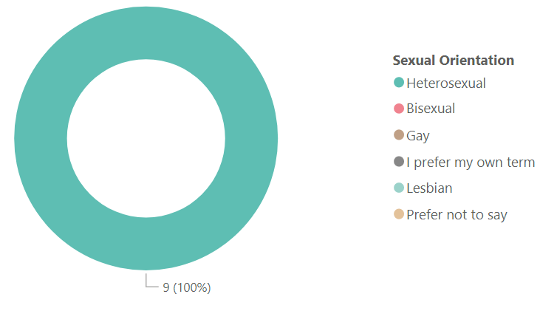

Religion profile

Education, Training & Development…
We deliver extensive mandatory training to all employees upon employment, and these are regularly refreshed with our employees, this includes Equality and Diversity training. As that aims to explore the legal, moral and business reasons why Equality and Diversity is important to the company. It considers the impact that personal behaviour can have on patients and colleagues and explores a range of practical tools to ensure we maintain positive professional relationships with patients and colleagues while at work.

Good examples and stories were used in my training.

The online course means I can refresh my knowledge at a convenient time.

Looking forward to 2023/2024
We remain committed to ensuring we are an equal opportunity employer that provides their employees with a fair and safe environment. The Group plans to further develop its key activity to reduce inequalities, including:
- continue anonymised recruitment to make sure we are shortlisting applicants based upon ability rather than characteristics
- Undertake further engagement work and improve equality analysis.
- Removing barriers or inequalities faced by protected groups accessing healthcare, including making reasonable adjustments.
- Work with our communities to understand their views and opinions when we are considering change

Conclusion
We aspire to be the employer and healthcare provider of choice in our contracted areas. With empowered, engaged and well supported staff and a workforce that represents the communities that we serve.

We want to ensure staff are consciously inclusive in their day –to-day practice and interactions with our patients and teams recognising their mix of abilities, experience and knowledge.

Our staff provide compassionate care and we adopt a patient centred approach to the care we provide. As an employer we strive to provide a very positive supportive workplace free from any form of bullying, harassment or discrimination.

Contact Us
If you have any questions about this report, or would like it in. different format, please contact us one:
CONTACT DETAILS:

Holly Hellstrom
Information Assurance Director
01482 908208 Option 5
Holly.hellstrom@nhs.net

